DeltaWare Systems Inc.

HL7 Test Harness Design

Version 1.1

Revision History
Date | Version | Description | Author
15-Jun-06 | 1.0 | Initial revision | Matthew Wicks
29-Jun-06 | 1.1 | Minor edits | Matthew Wicks

GNU General Public License
The HL7 Test Harness system is released under the GNU General Public License (GPL) Version 2. The following describes the terms and conditions of copying, distribution, and modification of this application as well as a warranty disclaimer.

Copyright (C) 2006 DeltaWare Systems Inc.

This program is free software; you can redistribute it and/or modify it under the terms of the GNU General Public License as published by the Free Software Foundation; either version 2 of the License, or (at your option) any later version.
This program is distributed in the hope that it will be useful, but WITHOUT ANY WARRANTY; without even the implied warranty of MERCHANTABILITY or FITNESS FOR A PARTICULAR PURPOSE. See the GNU General Public License for more details.
You should have received a copy of the GNU General Public License along with this program; if not, write to the Free Software Foundation, Inc., 59 Temple Place, Suite 330, Boston, MA 02111-1307 USA

The GNU General Public License (GPL)
Version 2, June 1991
Copyright (C) 1989, 1991 Free Software Foundation, Inc.
59 Temple Place, Suite 330, Boston, MA 02111-1307 USA
Everyone is permitted to copy and distribute verbatim copies
of this license document, but changing it is not allowed.
Preamble
The licenses for most software are designed to take away your freedom to share and change it. By contrast, the GNU General Public License is intended to guarantee your freedom to share and change free software--to make sure the software is free for all its users. This General Public License applies to most of the Free Software Foundation's software and to any other program whose authors commit to using it. (Some other Free Software Foundation software is covered by the GNU Library General Public License instead.) You can apply it to your programs, too.
When we speak of free software, we are referring to freedom, not price. Our General Public Licenses are designed to make sure that you have the freedom to distribute copies of free software (and charge for this service if you wish), that you receive source code or can get it if you want it, that you can change the software or use pieces of it in new free programs; and that you know you can do these things.

To protect your rights, we need to make restrictions that forbid anyone to deny you these rights or to ask you to surrender the rights. These restrictions translate to certain responsibilities for you if you distribute copies of the software, or if you modify it.
For example, if you distribute copies of such a program, whether gratis or for a fee, you must give the recipients all the rights that you have. You must make sure that they, too, receive or can get the source code. And you must show them these terms so they know their rights.

We protect your rights with two steps: (1) copyright the software, and (2) offer you this license which gives you legal permission to copy, distribute and/or modify the software.

Also, for each author's protection and ours, we want to make certain that everyone understands that there is no warranty for this free software. If the software is modified by someone else and passed on, we want its recipients to know that what they have is not the original, so that any problems introduced by others will not reflect on the original authors' reputations.
Finally, any free program is threatened constantly by software patents. We wish to avoid the danger that redistributors of a free program will individually obtain patent licenses, in effect making the program proprietary. To prevent this, we have made it clear that any patent must be licensed for everyone's free use or not licensed at all.
The precise terms and conditions for copying, distribution and modification follow.

TERMS AND CONDITIONS FOR COPYING, DISTRIBUTION AND MODIFICATION
0. This License applies to any program or other work which contains a notice placed by the copyright holder saying it may be distributed under the terms of this General Public License. The "Program", below, refers to any such program or work, and a "work based on the Program" means either the Program or any derivative work under copyright law: that is to say, a work containing the Program or a portion of it, either verbatim or with modifications and/or translated into another language. (Hereinafter, translation is included without limitation in the term "modification".) Each licensee is addressed as "you".
Activities other than copying, distribution and modification are not covered by this License; they are outside its scope. The act of running the Program is not restricted, and the output from the Program is covered only if its contents constitute a work based on the Program (independent of having been made by running the Program). Whether that is true depends on what the Program does.

1. You may copy and distribute verbatim copies of the Program's source code as you receive it, in any medium, provided that you conspicuously and appropriately publish on each copy an appropriate copyright notice and disclaimer of warranty; keep intact all the notices that refer to this License and to the absence of any warranty; and give any other recipients of the Program a copy of this License along with the Program.
You may charge a fee for the physical act of transferring a copy, and you may at your option offer warranty protection in exchange for a fee.

2. You may modify your copy or copies of the Program or any portion of it, thus forming a work based on the Program, and copy and distribute such modifications or work under the terms of Section 1 above, provided that you also meet all of these conditions:
a) You must cause the modified files to carry prominent notices stating that you changed the files and the date of any change.
b) You must cause any work that you distribute or publish, that in whole or in part contains or is derived from the Program or any part thereof, to be licensed as a whole at no charge to all third parties under the terms of this License.
c) If the modified program normally reads commands interactively when run, you must cause it, when started running for such interactive use in the most ordinary way, to print or display an announcement including an appropriate copyright notice and a notice that there is no warranty (or else, saying that you provide a warranty) and that users may redistribute the program under these conditions, and telling the user how to view a copy of this License. (Exception: if the Program itself is interactive but does not normally print such an announcement, your work based on the Program is not required to print an announcement.)
These requirements apply to the modified work as a whole. If identifiable sections of that work are not derived from the Program, and can be reasonably considered independent and separate works in themselves, then this License, and its terms, do not apply to those sections when you distribute them as separate works. But when you distribute the same sections as part of a whole which is a work based on the Program, the distribution of the whole must be on the terms of this License, whose permissions for other licensees extend to the entire whole, and thus to each and every part regardless of who wrote it.
Thus, it is not the intent of this section to claim rights or contest your rights to work written entirely by you; rather, the intent is to exercise the right to control the distribution of derivative or collective works based on the Program.
In addition, mere aggregation of another work not based on the Program with the Program (or with a work based on the Program) on a volume of a storage or distribution medium does not bring the other work under the scope of this License.

3. You may copy and distribute the Program (or a work based on it, under Section 2) in object code or executable form under the terms of Sections 1 and 2 above provided that you also do one of the following:
a) Accompany it with the complete corresponding machine-readable source code, which must be distributed under the terms of Sections 1 and 2 above on a medium customarily used for software interchange; or,
b) Accompany it with a written offer, valid for at least three years, to give any third party, for a charge no more than your cost of physically performing source distribution, a complete machine-readable copy of the corresponding source code, to be distributed under the terms of Sections 1 and 2 above on a medium customarily used for software interchange; or,
c) Accompany it with the information you received as to the offer to distribute corresponding source code. (This alternative is allowed only for noncommercial distribution and only if you received the program in object code or executable form with such an offer, in accord with Subsection b above.)
The source code for a work means the preferred form of the work for making modifications to it. For an executable work, complete source code means all the source code for all modules it contains, plus any associated interface definition files, plus the scripts used to control compilation and installation of the executable. However, as a special exception, the source code distributed need not include anything that is normally distributed (in either source or binary form) with the major components (compiler, kernel, and so on) of the operating system on which the executable runs, unless that component itself accompanies the executable.
If distribution of executable or object code is made by offering access to copy from a designated place, then offering equivalent access to copy the source code from the same place counts as distribution of the source code, even though third parties are not compelled to copy the source along with the object code.

4. You may not copy, modify, sublicense, or distribute the Program except as expressly provided under this License. Any attempt otherwise to copy, modify, sublicense or distribute the Program is void, and will automatically terminate your rights under this License. However, parties who have received copies, or rights, from you under this License will not have their licenses terminated so long as such parties remain in full compliance.

5. You are not required to accept this License, since you have not signed it. However, nothing else grants you permission to modify or distribute the Program or its derivative works. These actions are prohibited by law if you do not accept this License. Therefore, by modifying or distributing the Program (or any work based on the Program), you indicate your acceptance of this License to do so, and all its terms and conditions for copying, distributing or modifying the Program or works based on it.

6. Each time you redistribute the Program (or any work based on the Program), the recipient automatically receives a license from the original licensor to copy, distribute or modify the Program subject to these terms and conditions. You may not impose any further restrictions on the recipients' exercise of the rights granted herein. You are not responsible for enforcing compliance by third parties to this License.

7. If, as a consequence of a court judgment or allegation of patent infringement or for any other reason (not limited to patent issues), conditions are imposed on you (whether by court order, agreement or otherwise) that contradict the conditions of this License, they do not excuse you from the conditions of this License. If you cannot distribute so as to satisfy simultaneously your obligations under this License and any other pertinent obligations, then as a consequence you may not distribute the Program at all. For example, if a patent license would not permit royalty-free redistribution of the Program by all those who receive copies directly or indirectly through you, then the only way you could satisfy both it and this License would be to refrain entirely from distribution of the Program.
If any portion of this section is held invalid or unenforceable under any particular circumstance, the balance of the section is intended to apply and the section as a whole is intended to apply in other circumstances.
It is not the purpose of this section to induce you to infringe any patents or other property right claims or to contest validity of any such claims; this section has the sole purpose of protecting the integrity of the free software distribution system, which is implemented by public license practices. Many people have made generous contributions to the wide range of software distributed through that system in reliance on consistent application of that system; it is up to the author/donor to decide if he or she is willing to distribute software through any other system and a licensee cannot impose that choice.
This section is intended to make thoroughly clear what is believed to be a consequence of the rest of this License.

8. If the distribution and/or use of the Program is restricted in certain countries either by patents or by copyrighted interfaces, the original copyright holder who places the Program under this License may add an explicit geographical distribution limitation excluding those countries, so that distribution is permitted only in or among countries not thus excluded. In such case, this License incorporates the limitation as if written in the body of this License.

9. The Free Software Foundation may publish revised and/or new versions of the General Public License from time to time. Such new versions will be similar in spirit to the present version, but may differ in detail to address new problems or concerns.
Each version is given a distinguishing version number. If the Program specifies a version number of this License which applies to it and "any later version", you have the option of following the terms and conditions either of that version or of any later version published by the Free Software Foundation. If the Program does not specify a version number of this License, you may choose any version ever published by the Free Software Foundation.

10. If you wish to incorporate parts of the Program into other free programs whose distribution conditions are different, write to the author to ask for permission. For software which is copyrighted by the Free Software Foundation, write to the Free Software Foundation; we sometimes make exceptions for this. Our decision will be guided by the two goals of preserving the free status of all derivatives of our free software and of promoting the sharing and reuse of software generally.

NO WARRANTY

11. BECAUSE THE PROGRAM IS LICENSED FREE OF CHARGE, THERE IS NO WARRANTY FOR THE PROGRAM, TO THE EXTENT PERMITTED BY APPLICABLE LAW. EXCEPT WHEN OTHERWISE STATED IN WRITING THE COPYRIGHT HOLDERS AND/OR OTHER PARTIES PROVIDE THE PROGRAM "AS IS" WITHOUT WARRANTY OF ANY KIND, EITHER EXPRESSED OR IMPLIED, INCLUDING, BUT NOT LIMITED TO, THE IMPLIED WARRANTIES OF MERCHANTABILITY AND FITNESS FOR A PARTICULAR PURPOSE. THE ENTIRE RISK AS TO THE QUALITY AND PERFORMANCE OF THE PROGRAM IS WITH YOU. SHOULD THE PROGRAM PROVE DEFECTIVE, YOU ASSUME THE COST OF ALL NECESSARY SERVICING, REPAIR OR CORRECTION.

12. IN NO EVENT UNLESS REQUIRED BY APPLICABLE LAW OR AGREED TO IN WRITING WILL ANY COPYRIGHT HOLDER, OR ANY OTHER PARTY WHO MAY MODIFY AND/OR REDISTRIBUTE THE PROGRAM AS PERMITTED ABOVE, BE LIABLE TO YOU FOR DAMAGES, INCLUDING ANY GENERAL, SPECIAL, INCIDENTAL OR CONSEQUENTIAL DAMAGES ARISING OUT OF THE USE OR INABILITY TO USE THE PROGRAM (INCLUDING BUT NOT LIMITED TO LOSS OF DATA OR DATA BEING RENDERED INACCURATE OR LOSSES SUSTAINED BY YOU OR THIRD PARTIES OR A FAILURE OF THE PROGRAM TO OPERATE WITH ANY OTHER PROGRAMS), EVEN IF SUCH HOLDER OR OTHER PARTY HAS BEEN ADVISED OF THE POSSIBILITY OF SUCH DAMAGES.
END OF TERMS AND CONDITIONS

Table of Contents
1 Introduction 1
1.1 Purpose 1
1.2 Scope 1
2 User Interface 2
2.1 Application 2
2.2 Test Result Panel 3
2.3 Configuration Panel 4
2.3.1 Message Proxy Panel 4
2.3.2 Client Simulator Panel 5
2.3.3 Server Simulator Panel 6
2.3.4 Work Flow Details 7
2.3.5 Test Data 8
2.4 HTML Test Report 9
3 System Architecture 10
3.1 System Configuration 10
3.1.1 Client system 10
3.1.2 Server systems 10
3.1.3 Client Simulator 10
3.1.4 Server Simulator 11
3.1.5 Message Proxy 11
3.1.6 Message Validator 11
3.1.7 Message Constructor 11
3.1.8 Data Logger 11
4 Component Architectures 12
4.1 Message Proxy 12
4.2 Message Validator 12
4.3 Message Constructor 13
4.4 Client Simulator 14
4.5 Server Simulator 15
5 Work Flow Document 16
5.1 Xml Format 17
5.1.1 Workflows node 18
5.1.2 Reference nodes 18
5.1.3 Workflow node 18
5.1.4 Message node 18
5.1.5 Request node 18
5.1.6 Response node 18
5.1.7 MessageProxy node 18
5.1.8 Simulator node 19
5.1.9 Validation node 19
5.1.10 Construction node 19
5.1.11 Rule node 19
6 Configuration and Log Files 20
6.1 Test Results Log File 20
6.1.1 Xml Log File 20
6.1.2 Html Log File 20
6.2 History Log File 20
6.3 Test Data File 21
6.3.1 Test Data 21
6.3.2 System 21
7 Simulators 22
7.1 Client Simulator 22
7.1.1 Message Flow 22
7.2 Server Simulators 22
7.2.1 Message Flow 22

Introduction

Purpose
The HL7 Test Harness system is a conformance testing application that provides the ability to simulate the message processing actions of a client and/or server system. The application provides work flow testing, message format testing and message content testing with or without the other system being present via configurable work flow and validation files. This will provide the ability for application developers to build and test an application that will conform to a standard set of validation tests.
Compliances will be tested by running a set of predefined work flows. Each work flow will represent an action that the end user is expected to perform. Examples of such user performed actions would be a pharmacist that wishes to dispense a drug to a client, or a doctor diagnosing an allergy for a patient.
The end user actions can represent many HL7 messages that the system must support and send or receive in a given order. The order that messages are sent is very important to compliance and the Test Harness will have very rigid rules with regards to the order of messages.

Scope
This document will include design level detail for the components that make up the Test Harness. This document does not include the actual tests or messages that would be created to test compliance.

User Interface

Application
The Test Harness application will be a Windows bases application that acts as a proxy server and can verify messages being sent between the client system and multiple servers via a single port. The Test Harness will also have the ability to simulate the client or server applications.
The application has two main panels. The Test Results panel on the left and the Configuration panel on the right.
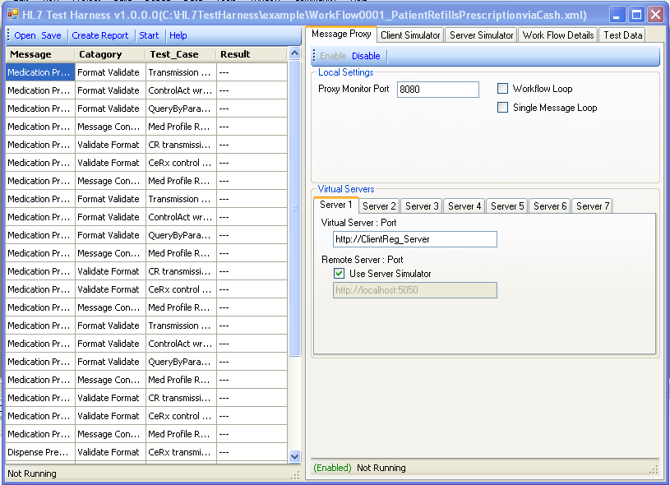

Test Result Panel
The Test Results panel contains a test results table extracted from the work flow document that is loaded into the system. It will also have the ability to open new work flows or test result files, save the current test results to a file and create an html report from the test results.
Results will be updated in the data grid as tests are executed. The application will also provide the ability to save test results to an xml file, via the Save button, and Create html report, via the Create Report button.
The Start/Stop button is used to control the Test Harness processes. This button will start or stop all enabled processes (client simulator, server simulator and/or message proxy)
The current status of the Test Harness will be displayed on the status bar at the bottom of this panel.
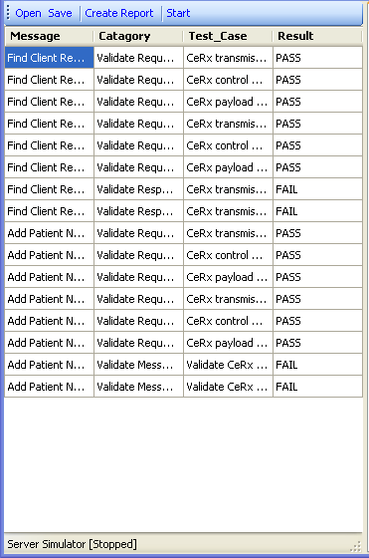

Configuration Panel
The Configuration panel consists of several tabs used to configure the different elements of the Test Harness. These configurable elements include the Message Proxy, Client Simulator, Server Simulator, Work Flow Details and Test Data. Each element will be described in the sections that follow.

Message Proxy Panel
The Message Proxy configuration panel gives the user the ability to enable and disable the proxy server. While the Test Harness is not running, the user will be able to configure the local port the system will monitor and map virtual servers to real world addresses and ports.
Virtual servers are provided to allow users to run the same set of work flows against different servers with out changing the work flow.

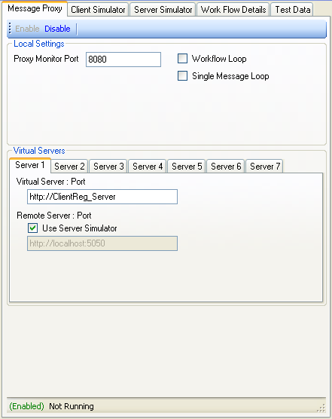

Client Simulator Panel
The Client Simulator panel allows the user to enable or disable the client simulator as well as view the previous messages sent and received by the simulator. The client simulator is started and stopped with the use of the start/stop button on the Test Results page.

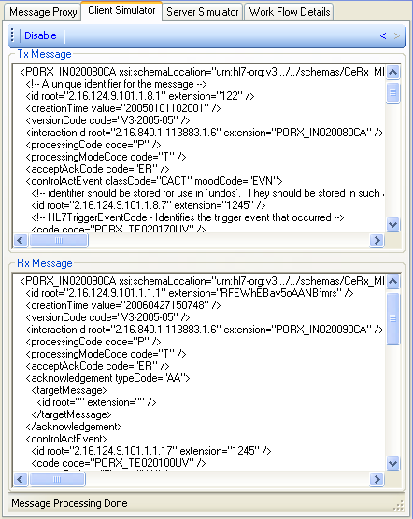

Server Simulator Panel
The Server Simulator panel allows the user to enable or disable the server simulator as well as view the previous messages sent and received by the simulator. The server simulator is started and stopped with the use of the start/stop button on the Test Results page.

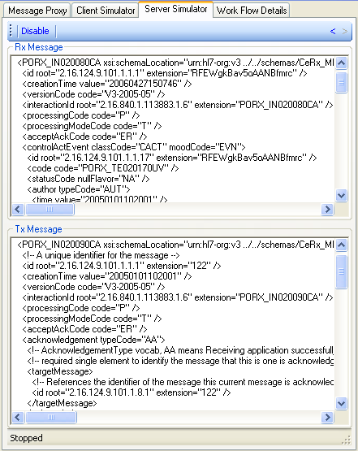

Work Flow Details
The Work Flow Details panel allows the user to view the work flow details in an xml tree format. The panel will show the state of each test with a check mark for passed, X for failures or an empty square to show that no status is available. The xml tree will auto expand to show any failed cases.

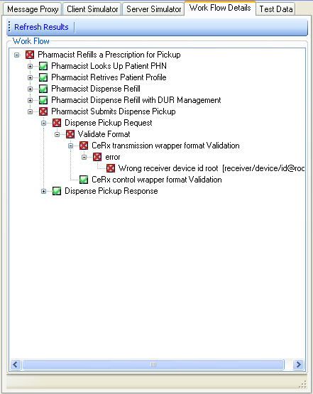

Test Data
The Test Data panel shows the data used by the Message Proxy for mapping between the client and server systems. This panel allows the user to load and save test data files as well as restage data for either the client or server systems.

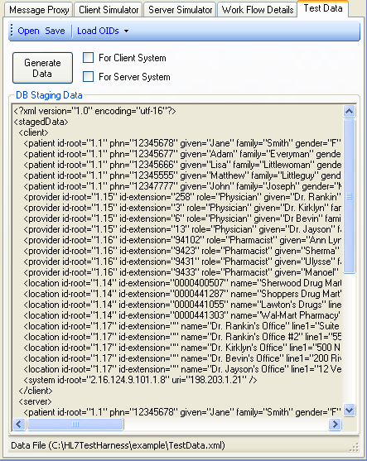

HTML Test Report
The following report will be created by the Test Harness application.
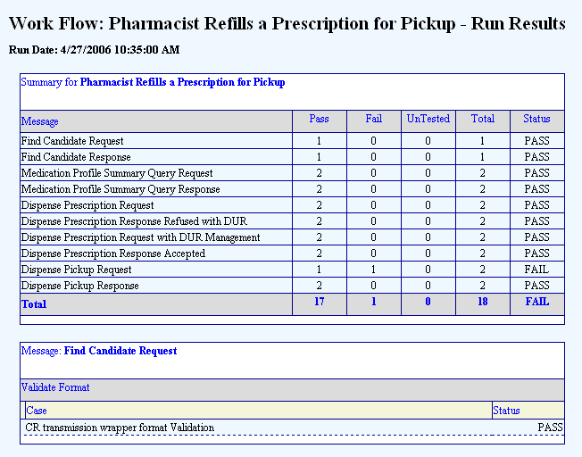
…
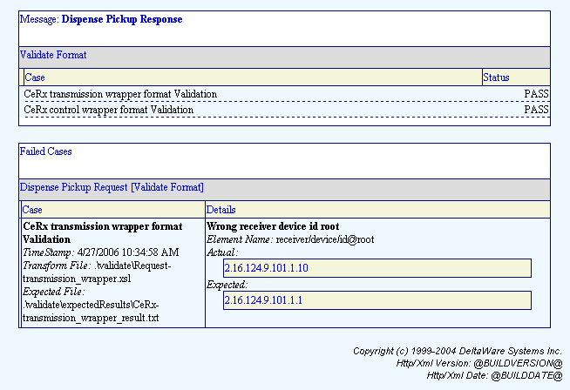

System Architecture

System Configuration
The HL7 Test Harness application is configurable to connect to live client and server systems as well as simulate either the client and/or server systems. Each of the components of the system represented in this diagram will be described in the following sections.
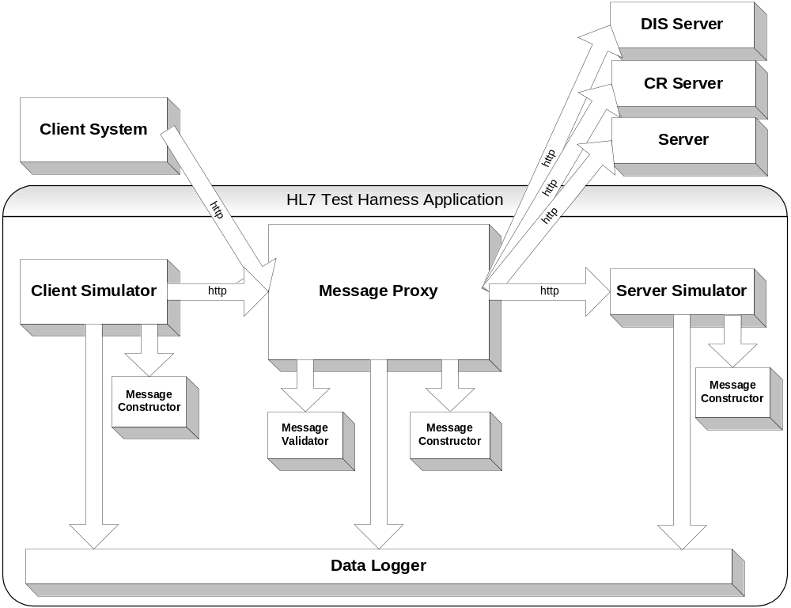

Client system
This represents a client system under test. A compliant client system must follow the workflows that are loaded into the Test Harness application.

Server systems
This represents a server system under test. Multiple servers can be connected. Compliant server systems must follow the workflows that are loaded into the Test Harness application.

Client Simulator
The Client Simulator is a static message generator. Messages will be generated by the simulator to be sent to one of the available servers.
The set of static messages to be sent will be configured by the work flow configuration files.

Server Simulator
The Server Simulator is a static response message generator. Messages will be generated by the simulator to be sent back in response to a request made by the client software.

Message Proxy
The Message Proxy will sit between the client system and the available servers. It will be responsible for mapping messages from the requesting client system to the appropriate server as determined by the proxy setup.
The Message Proxy will also pass messages to both the message validator and message constructor before passing the message to the next system.

Message Validator
The Message Validator will accept both request and response messages from the Message Proxy and provide validation of conformance at the message and work flow levels.

Message Constructor
The Message Constructor will accept both request and response messages from the Message Proxy and provide any message translation that is required as defined by the work flow files. The resulting translated message will be returned to the Message Proxy to replace the actual request or response that is being sent.

Data Logger
The Data Logger will provide logging capabilities to the Message Proxy, Client Simulator and Server Simulator. This data will be displayed in the Test Harness Test Results panel and stored in xml and html file formats.

Component Architectures

Message Proxy
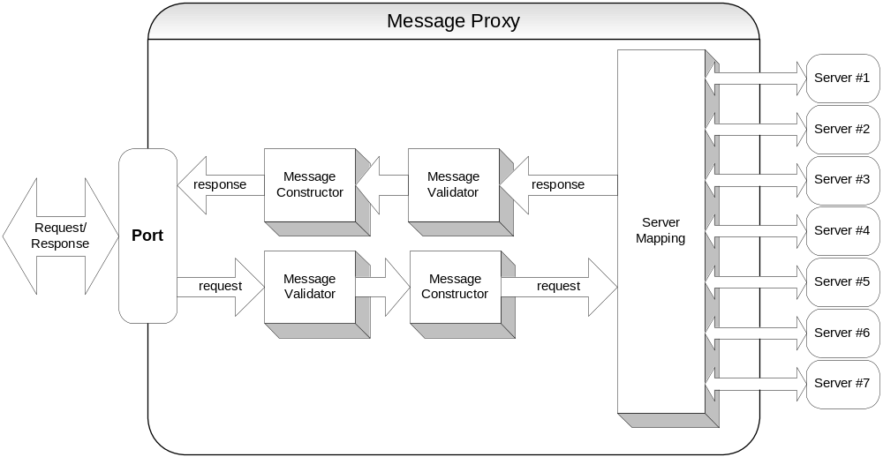
The Message Proxy will be setup as a proxy server on a static port of the local system. All messages sent to the virtual server list will be captured, validated, modified as required and resent to the requested server. The Message Proxy will have the ability to map requests to different servers and ports so that changing a set of tests to be run against a new server would not require changing of work flow messages.

Message Validator
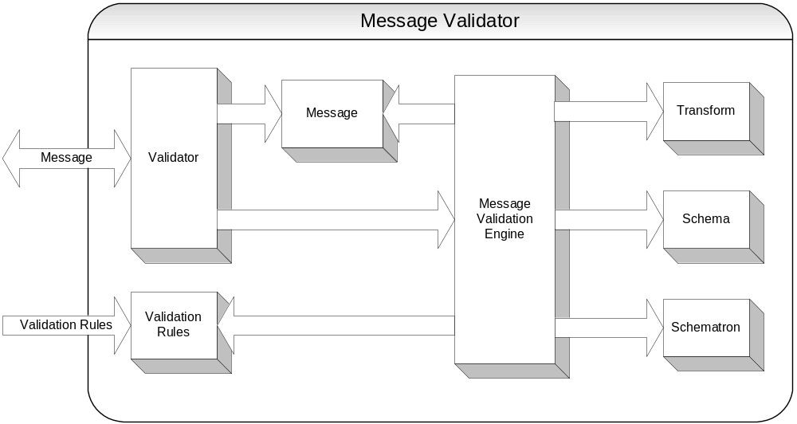
The role of the Message Validator is to apply a set of validation rules against a message. The validation rules will consist of transform validation. The transform will be preformed and the results will be compared against an expected results message contained with in the validation rule.
The validation rules will be loaded into the Message Validator at the beginning of the work flow. The format of these rules will be described in detail in a later section of this document.

Message Constructor
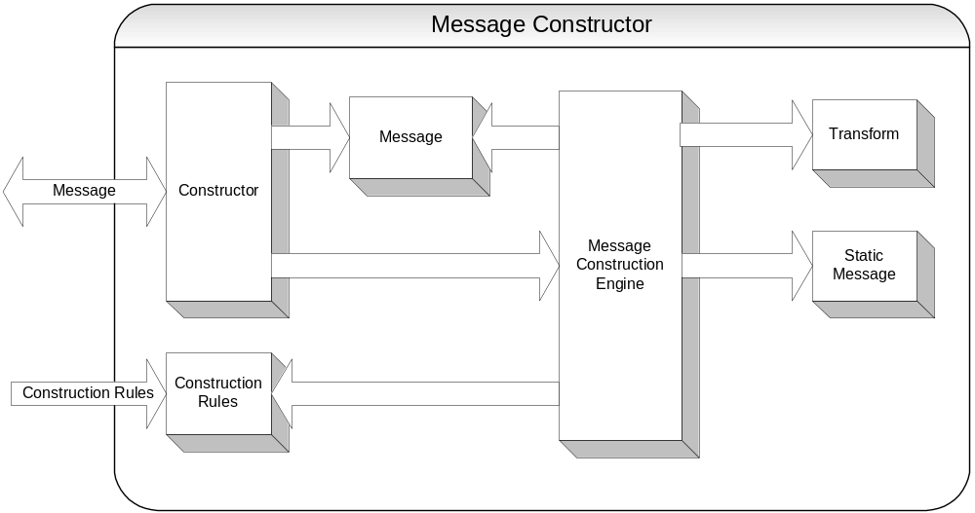

The role of the Message Constructor is to modify both request and response messages as per the construction rules. The construction rules can consist of transforms and/or static message loads. These rules will allow for such things as changing a message so that the patient in the message is always the same age no mater when the message is sent. This would be done by changing the patients birth date. Another example of modification is that replay messages maybe modified to always have the same ID, or same sender information, etc.
The Message Proxy, Client Simulator, and Server Simulator will all have access to an instance of the Message Constructor to provide the means of generating the messages that are required for their operation. It would be expected that both the Client and Server Simulators would make use of static message loads while the Message Proxy will likely use transforms to modify the messages that are being passed between client and server systems.
Construction rules will be described in more detail in a later section of this document.

Client Simulator
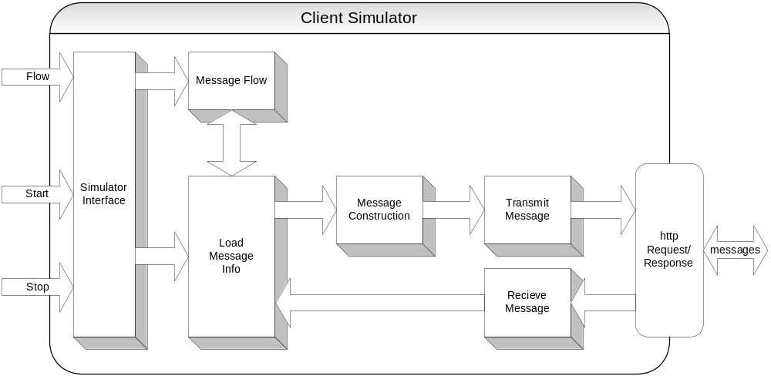

The Client simulator will be the only active application. It will accept a work flow file that it will then use to construct request messages and expected response messages. The Client Simulator will continue to send request messages until either the end of the work flow is reached or a communication time out occurs.
All messages that are transmitted will be sent to predetermined server addresses as defined in the message flow. It will be the responsibility of the Message Proxy to map these addresses to the actual servers that are to be tested.
The Client Simulator object will implement start, stop and load (workflow) interfaces. This interface will be used by the HL7 Test Harness UI to control the simulator. The details of the flow information will be described later in this document.

Server Simulator
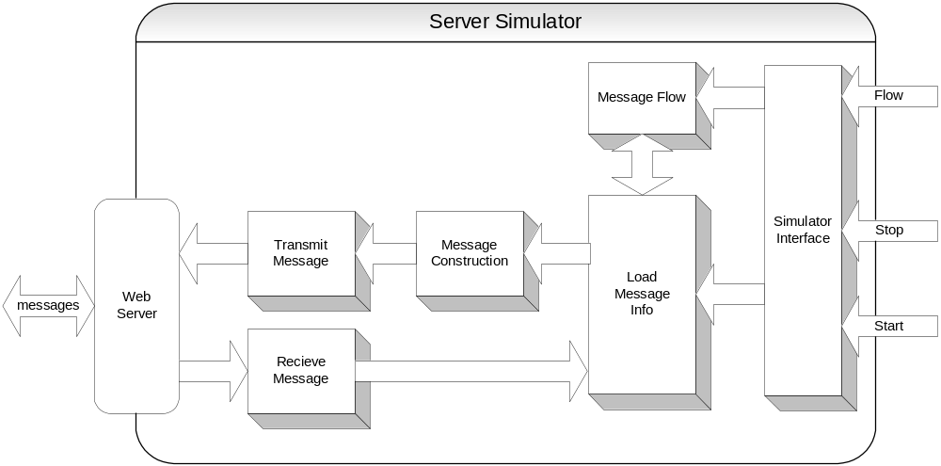
The Server Simulator will be a passive application. It will be setup as a web server that will listen on a static port on the local machine. It will be the responsibility of the Message Proxy to redirect request messages to this local port when testing is to be preformed against the Server Simulator.
Once a request message is received by the Server Simulator, it will construct a response message based on the loaded message flow and transmit that response.
The Server Simulator object will implement start, stop and load (workflow) interfaces. This interface will be used by the HL7 Test Harness UI to control the simulator. The details of these interfaces and the message flow information will be described later in this document.

Work Flow Document
The work flow xml document describes a set of work flows. Each work flow describes the order and content of the messages that are required to execute that given work flow. Work flows are real world processes such as adding a patient note or sending in a prescription for a patient. In both cases, the client software needs to send multiple request messages to the servers to get the required information to complete the request. In the example of adding a patient note, the client software would need to send the following messages:
- Find client
- Get client demographics
- Add patient note
Data from the work flow xml document will be used by the Message Proxy, Client Simulator and Server Simulator to verify message order and content as well as to construct request and response messages.

Xml Format
The following diagram displays the format of the workflows xml document. Each section will be described in detail in the following sections.

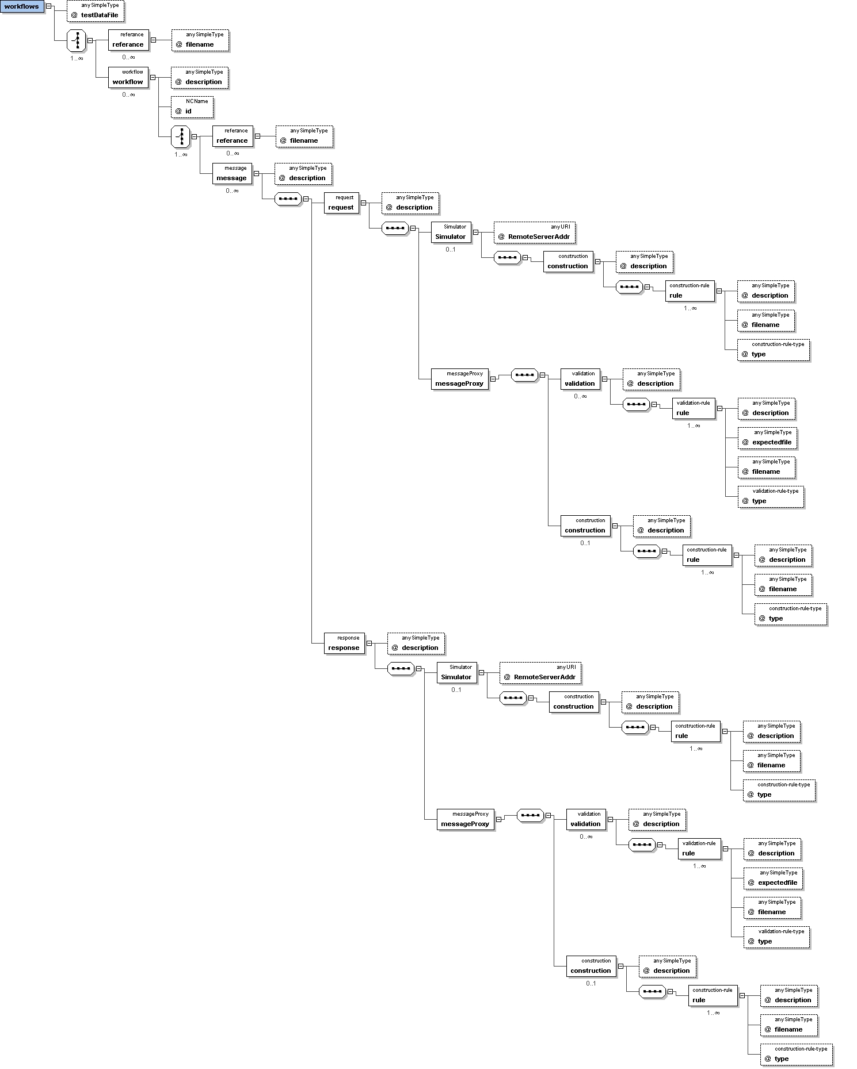

Workflows node
The workflows node is the top level element. It contains a set of workflow elements that will be executed in the order that they appear.

testDatafile attribute
Text attribute containing the file name of the test data file to be used by the workflow process.

Reference nodes
A reference node can be placed either under the workflows or workflow nodes. It has a single attribute filename. When the workflow is loaded by the Test Harness, the reference nodes are replaced with the data found with in the workflows of the files referenced. If the reference element is placed within the workflows node, all workflow elements and sub elements of the reference file will be imported. If the reference element is placed within the workflow node, all message elements and sub elements in the reference file will be imported.

filename attribute
Text attribute containing the file name of another workflow document that is to be included in the place of the reference node.

Workflow node
The workflow node contains all the messages that are sent between the client software and the server software to complete a given task. This represents an actual real world action such as prescribe a drug to a patient.

Description attribute
Text attribute that describes the task that the work flow is to achieve. This should describe what the work flow is doing and what type of test is being run.

Message node
The message node represents an HL7 message request and response pair.

Description attribute
Text attribute to describe the HL7 Message set that will be used. This would not be the actual message name, but the message intent (e.g. Find Client or Get Client Demographics).

Request node
The request node represents the actual HL7 request message.

Description attribute
Text attribute to describe the message. Should be set to the actual name of the message.

Response node
The request node represents the actual HL7 response message.

Description attribute
Text attribute to describe the message. Should be set to the actual name of the message.

MessageProxy node
The MmessageProxy node contains the validation and construction elements used by the Message Proxy application.

Simulator node
The simulator node contains the construction element used by the Client and Server Simulators to create request or response messages.

VirtualServer attribute
The virtualServer attribute contains the address that the messages are to be sent to. This can be mapped by the Message Proxy to a real world address and port.

Validation node
The validation node contains the set of validation rules to be used against the received message. Validation is done before message construction is preformed.

Construction node
The construction node contains the rules used to construct or modify messages. When present, in the messageProxy node this will modify the message before passing the message to the next application. When present in the Simulator tag, this will construct the message to either respond to a request or create the actual request.

Rule node
The rule node is used to describe either a validation rule or a construction rule.

Description attribute
Text attribute to describe what the rule is performing, either the type of test that is being run or the type of message that is being created.

Type attribute
Attribute that indicates the type of validation or construction that is being preformed. Available type for validation is transform. Available types for construction are transform and static.

Filename attribute
Text attribute containing the file name of the file to be used in the validation or construction method. This is the actual static message or transform file name.

ExpectedFile attribute
Text attribute containing the file name of the file to be used to compare validation results against. This is what is used to determine if the validation was successful.

Configuration and Log Files

Test Results Log File

Xml Log File
The Log File xml document will be in the same format as the WorkFlows xml document, but will have new attributes and sub nodes added. A status attribute, timestamp attribute and the details node will be added to rule, request and response nodes.

Status Attribute
A status attribute will be added to represent the overall status of all tests conducted beneath that node. For example, the status attribute of the WorkFlows node will provide the overall test status of all work flows run in the file. The status attribute for an Action node would provide the status of only those items preformed during that action.
Where a status is displayed to summarize sub nodes, such as in the above example, the following rules will determine the summarizing status (in this order):
Status = exception: where any sub status = exception
Status = failure: where the above items are false and any sub status = failure
Status = warning: where the above items are false and any sub status = warning
Status = pass: where all sub status = pass

TimeStamp Attribute
A timestamp attribute will be added to each rule, request and response node to indicate what time either the rule was executed or the request or response message was received.

Test Details node
Output from test results will be added as a sub node of the rule that created the output. RxMessage and TxMessage nodes will also be added to each request and response node to hold the actual message that were received and transmitted.
Data held with in the test details node that compiles with xml formatting rules will be stored as provided. Text that does not conform to xml rules will be placed inside a CDATA tag.

Html Log File
The Test Harness application will provide a report generator that will convert the log file from xml to html. This is done with the use of a style sheet that is contained with in the application directory.

History Log File
The Test Harness will create a history xml file log that can be used by the validation and construction transform style sheets. The history file will contain request and response messages that have been received and sent by the Message Proxy. The history file will be in the following format:
<history xmlns="urn:hl7-org:v3">
<request>
<client>
<!-- Message received from client system -->
</client>
<server>
<!-- Message sent to server system (after transform applied) -->
</server>
</request>
<response>
<server>
<!-- Message received from server system -->
</server>
<client>
<!-- Message sent back to client system (after transform applied) -->
</client>
</response>
</history>

Test Data File
The Test Harness uses a Test Data File to setup the mappings between the data received from the client messages and the data that is actually sent in the server messages. This file will also be used to map the response data back the client message elements.
The purpose of this file is to provide a single place where staged data is updated in the Test Harness. This should greatly reduce the amount of work needed before each test run.
The configuration file contains two main sections, the Test Data section and the System section.

Test Data
The purpose of the Test Data section of the Test Data File is to provide a single place where data that will change between test runs (staged data) is updated. The data held with in this section will contain such things as patient, provider and delivery location data. Each section will contain mapping of server data to client data. This data is used to update requests from the client system so that the data held within the message is valid as seen by the server system, it is also used to update response messages from the server before returning the response to the client system so that data held with in the response message will correspond to the request message.

System
The purpose of the system section of the configuration file is to provide a location to change system-to-system differences. This would include such things as the OIDs used for each section of the message, as well as the client and server identifying data that is held within the receiver and sender tags of the transmission wrapper. Mappings between the client and server systems is provided so that when a system is being tested, there is no need to update individual test messages.

Simulators

Client Simulator
The Client Simulator is meant to replace the need for a live client system when testing a DIS, CR, etc. server. The simulator will send the required messages to execute a work flow so that the Message Proxy can verify responses from the server that is being tested. For this reason, the Client Simulator is setup to simply send a message, wait for a response, then send the next message.

Message Flow
The Test Harness will provide to the Client Simulator a copy of the work flow xml document. The simulator will then use the request/simulator nodes to determine what messages to send and in what order.

Server Simulators
The Server Simulator is meant to replace the need for a live DIS, CR, etc. server when testing client software. The simulator will respond to requests from the client system with messages as defined by the work flow. The Message Proxy can then verify the order and format of the requests messages from the client system. For this reason, the Server Simulator is setup to simply replay to a request with the next message in the workflow, then wait for another request. The server simulator will stop responding to requests after the work flow has finished or if the user presses the stop button.

Message Flow
The Test Harness will provide to the Server Simulator a copy of the work flow xml document. The simulator will then use the response/simulator nodes to determine what messages to respond with and in what order to send those response messages.

